1 : 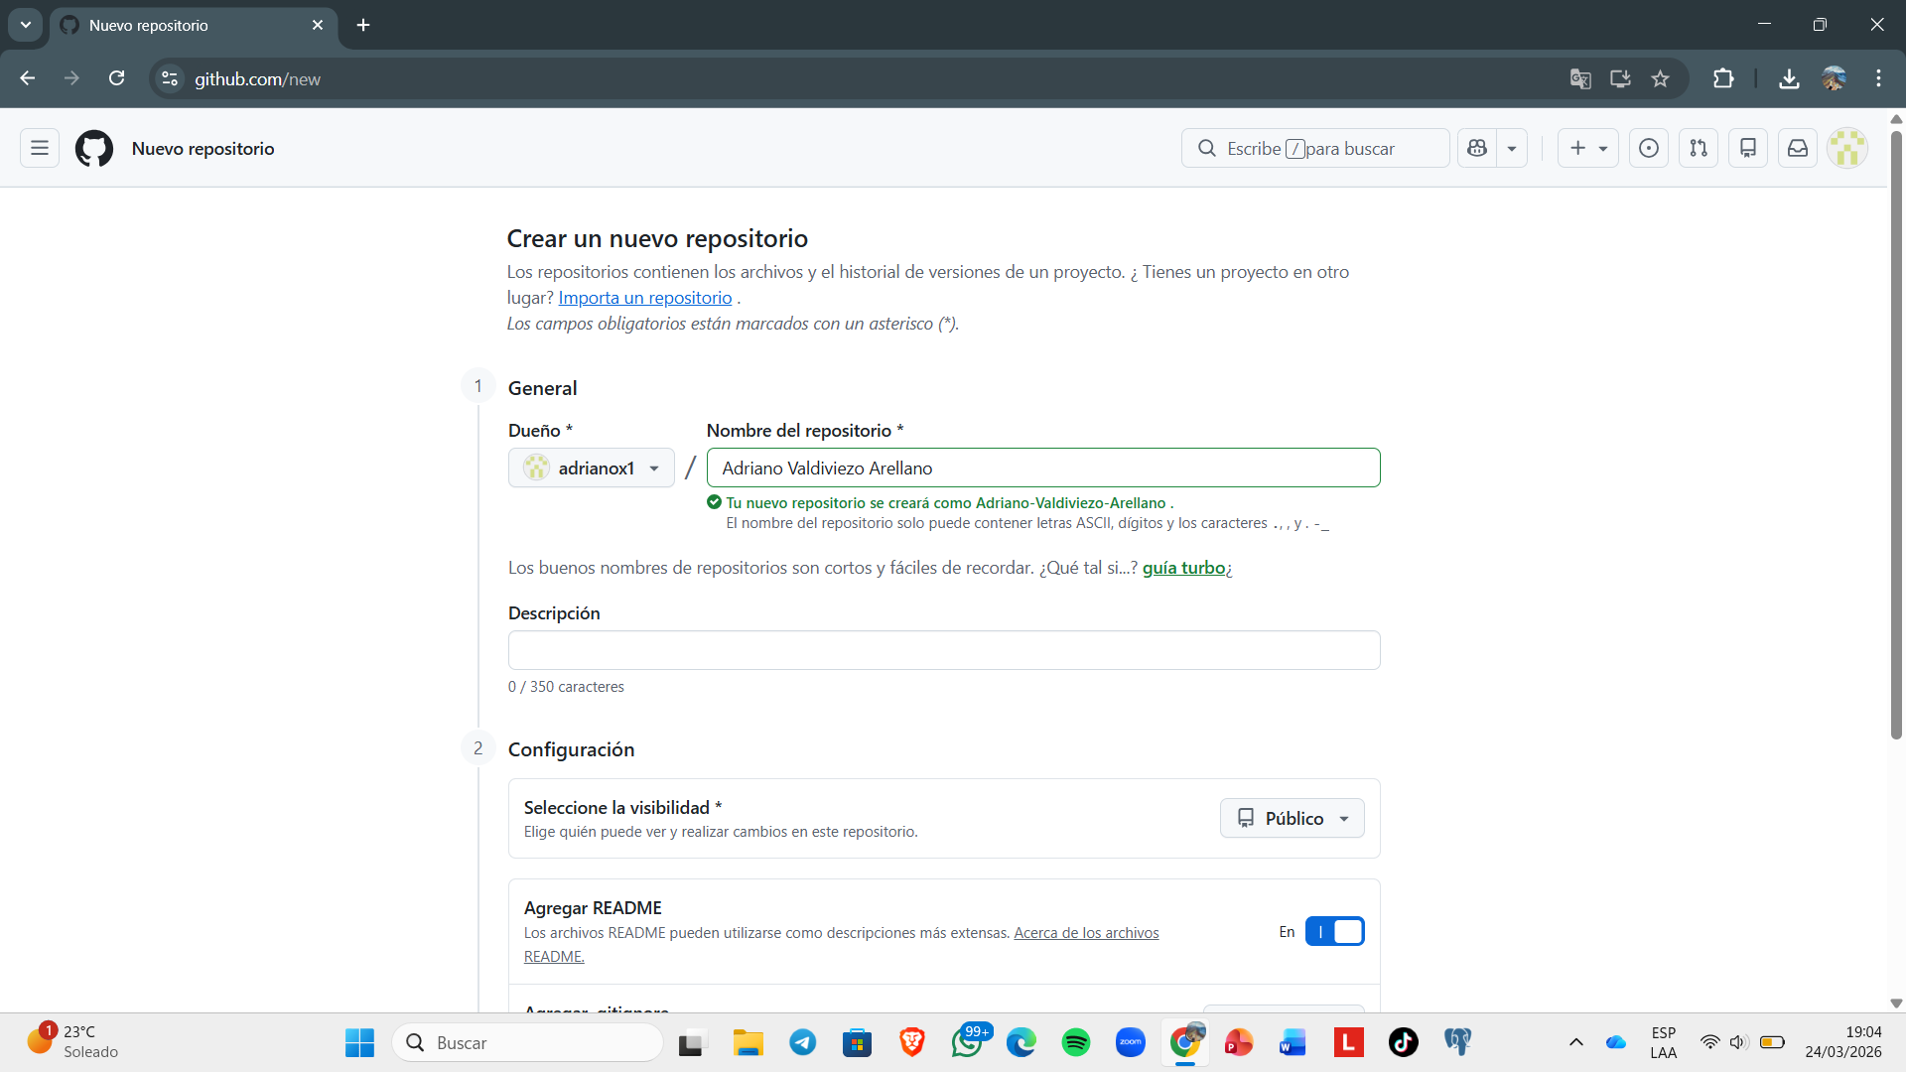

2 : 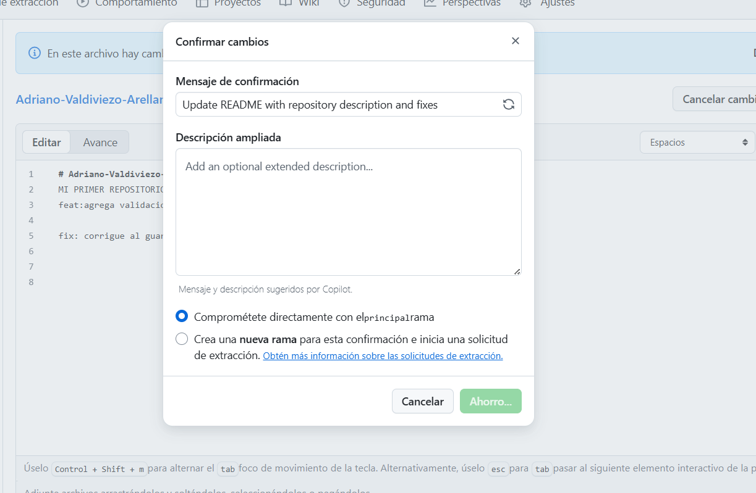

3 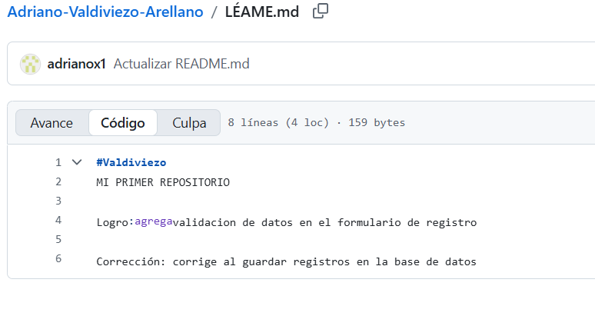

4: https://github.com/adrianox1/Adriano-Valdiviezo-Arellano.git

